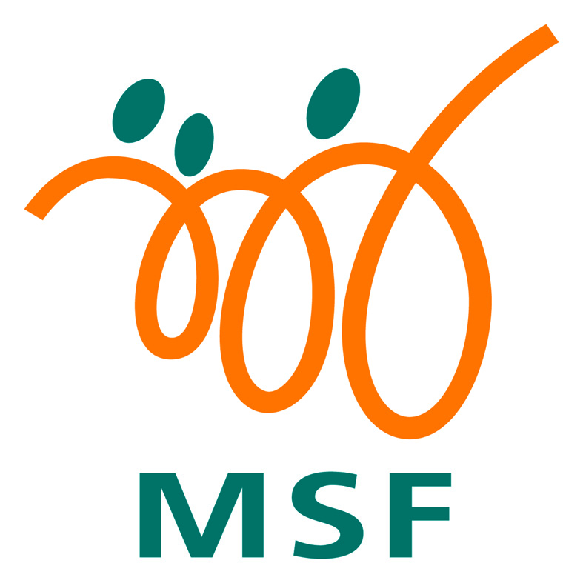
y CONSENT FOR COLLECTION, USE AND SHARING
OF PERSONAL INFORMATION

INTRODUCTION
- What is this document for?
- It lets you agree to share your information, as well as the information of someone you can legally act on behalf of, with the Singapore Public Agencies and Participating Organisations.
- This is not a form to apply for a scheme or service.

- How will it benefit me?
- By signing this form, the Singapore Public Agencies and Participating Organisations can better serve you and the other person, with relevant service(s) or scheme(s) when needed.
- For future service(s) or scheme(s) that you or the other person may need, you will not be required to fill out this form again as your consent will be valid until it is withdrawn.
- For more information, visit the Consent Management page or scan the QR code below.
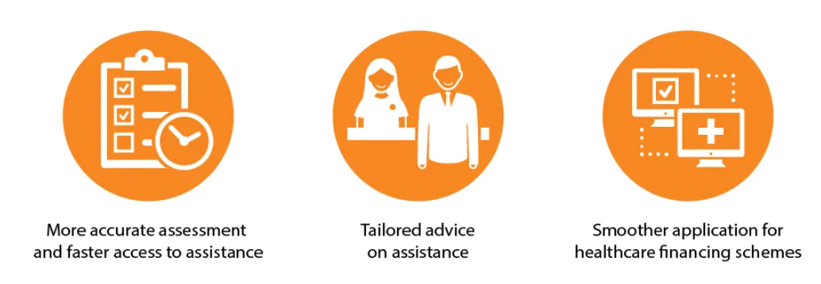 |  |  | 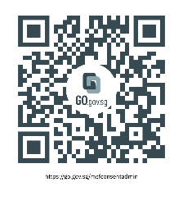  Scan for more info

- Who can I give consent for?
- Myself
- My child(ren)/ward(s) below 21 years old
- A mentally incapacitated individual whom I can legally act on behalf of

INSTRUCTIONS
- It will take about 10 minutes to fill this form.
- Please refer to the table below and complete the necessary sections:

I am providing consent for… | Sections to Complete | Documents Required
Myself | A and C | - My NRIC / other Identification Documents (ID) (Front and back)
My child(ren)/ward(s) below 21 years old | A, B1 and C | - My NRIC / other ID (Front and back) of the minor(s) and their parent / legal guardian  - Proof of Relationship (e.g. birth certificate, guardianship order or voluntary care agreement)
A mentally incapacitated individual whom I can legally act on behalf of* | A, B2 and C | - NRIC / other ID (Front and back) of the individual and their Donee(s) / Deput(ies)  - Registered Lasting Power of Attorney / Court Order
* For joint donee(s) or deput(ies) that is not listed under Section A, please complete Annex A and submit it with this form.

Section A – Details of Applicant
Please tick where relevant
I wish to provide consent for someone I can legally act on behalf of.
I wish to provide consent for myself and someone I can legally act on behalf of.
My Full Name: | ID No.:
 | * Select corresponding ID type
 | NRIC | Special Pass
 | Birth Certificate | Foreign Passport No
 | FIN
Section B1 – Consent on Behalf of My child(ren)/ward(s) below 21 years old
I am providing consent as the parent / legal guardian of the following individual(s), who is / are under 21 years old.

Please indicate the details of the individual(s) that you are giving consent on behalf of:
S/N | Name of Individual | ID No. of Individual | ID Type  * Select corresponding ID type
1
  NRIC | Special Pass
  Birth Certificate | Foreign Passport No.
  FIN
2
  NRIC | Special Pass
  Birth Certificate | Foreign Passport No.
  FIN
3
  NRIC | Special Pass
  Birth Certificate | Foreign Passport No.
  FIN
4
  NRIC | Special Pass
  Birth Certificate | Foreign Passport No.
  FIN
5
  NRIC | Special Pass
  Birth Certificate | Foreign Passport No.
  FIN
* If there are more than five individuals, please use a new form.

Section B2 – Consent on Behalf of Mentally Incapacitated Individual
Please tick where relevant
I am acting under a Registered Lasting Power of Attorney granted by the following individual; or
I am appointed by the Court under the Mental Capacity Act 2008 to act on behalf of the following individual.
Please indicate the details of the individual that you are giving consent on behalf of:
S/N | Name of Individual | ID No. of Individual | ID Type  * Select corresponding ID type
1
  NRIC | Special Pass
  Birth Certificate | Foreign Passport No.
  FIN

Section C – Consent and Acknowledgement by Applicant / Other Individual(s)
- I understand that the Singapore Public Agencies and Participating Organisations require my Personal Information for the following operational and analytical purposes:
  - to verify the identity and relationship of me and my family, for the Services or Schemes;
  - to conduct outreach to me and my family to inform us about, and to encourage us to apply for, the Services or Schemes;
  - to determine the eligibility of me and my family for the Services or Schemes;
  - to provide me and my family with the Services or Schemes;
  - to refer me and my family to other Services or Schemes not currently provided to us, if assessed to be useful to me and my family; and
  - for data analysis, research, evaluation and policy-making, for the Services or Schemes.

- I consent and agree that the Singapore Public Agencies and Participating Organisations may collect, use, and disclose my Personal Information for the purposes stated in Paragraph 1 and any other purpose permitted by law. I also consent and agree to the disclosure of my Personal Information to law enforcement officers. I understand that if there are any discrepancies in the Personal Information collected, such discrepancies may be reflected to the relevant Singapore Public Agencies, so that they may take the necessary steps to rectify any inaccurate records relating to me.

- My consent shall remain valid until I withdraw it in writing. I accept that it will take up to 10-15 working days from the date of receipt before the withdrawal of consent takes place.

- I have read and understood this consent form fully, including the attached Terms of Consent. I declare that the information that I have provided is accurate as at the time I sign this form.

Signature / thumbprint of Applicant / Family Member  (As stated under Section A) | Date:
Section D – To Be Completed by Officer (If Applicable)
I have sighted and verified all the physical / digital NRIC and / or Birth Certificate provided by the listed individual(s) under Section A, B1 and / or B2.
For non-English speaking Applicant(s), I have arranged for the information in this form to be interpreted to the applicant in Choose an item.at the time of signing this form.
Name of Officer | Date:
Division/Branch:
Designation:
Signature/Official Stamp:

TERMS OF CONSENT
- I understand and agree that these terms used in the consent form have the following definitions:
              - “Personal Information” includes the following but is not limited to:
                - Demographic information (e.g., bio-data comprising name, NRIC/FIN number, address, date of birth, sex, nationality, ethnicity, family/household structure and relationships);
                - Financial and social assistance data (e.g., financial, and social assistance history, income supplements, assessments for eligibility/suitability and details of services by the Singapore Public Agencies and Participating Organisations comprising social services, community agencies; and social worker case reports);
                - Medical and Health information (e.g., medical reports, functional assessment reports, healthcare bills and assistance, records of healthcare visits, means-tests results on subsidy rates, medical condition, diagnosis, and history);
                - Housing information (e.g., electricity, gas and water utilities, details for home ownership, rental housing, open market HDB rental, details on ownership of private property);
                - Employment and training information (e.g., current, and past employment details, last drawn salary, training subsidies, business ownership);
                - Education information (e.g., schooling records, pre-school enrolment, bursaries, tuition);
                - Financial data (e.g., source of income, maintenance information, insurance coverage, bank account details such as balance, transactions, number of savings and current accounts);
                - my income or items of income information from the Comptroller of Income Tax/Inland Revenue Authority of Singapore (IRAS);
                - information relating to and derived from my CPF Account(s) and CPF contributions (e.g., CPF Account(s) balance, CPF contribution details, CPF lumpsum withdrawal details, CPF monthly pay-outs) from the Central Provident Fund Board (CPF Board);
                - information relating to my participation in any scheme administered by the CPF Board (e.g., Dependent Protection Scheme, Silver Support Scheme, CPF Investment Scheme, CPF amount used for housing); and
                - Other information (e.g., immigration records, criminal offences, credit reports, and other information provided by me for the evaluation and administration of social services and public assistance schemes).

              - “Family” refers to anyone related to me by blood, marriage (including step-children and in-laws) or legal adoption, whether they live together with me.

              - “Services or Schemes” refer to services or programmes provided by any Singapore Public Agency or Participating Organisation, including new services or programmes that may be added from time to time, to support and render assistance to individuals and/or households, including:
    - healthcare, mental health, social development and support, family development and support, early childhood development, aged care, childcare, education, employment, housing, social assistance, pro-active outreach to assess eligibility, case assessment, case coordination and counselling services and schemes, disability services;
    - any form of financial assistance such as subsidies, grants, waivers, exemptions, tax reliefs, vouchers, or bursaries; and
    - schemes administered by the CPF Board.

              - “Singapore Public Agencies” includes, (a) the Government, including any ministry, department, agency, or organ of State, (b) any tribunal appointed under any written law, and (c) any statutory body, but excludes a Town Council established under section 4 of the Town Councils Act 1988.

              - “Participating Organisations” refer to any organisation which has been authorised by a Singapore Public Agency to provide the Services or Schemes.

- This consent shall be governed by and construed in accordance with the laws of the Republic of Singapore.

ANNEX A: Joint Donee / Deputy Form
For joint donee(s) or deput(ies) that is / are not listed under Section A of the OneMSF Omnibus Consent Form, please complete this form and submit it with the OneMSF Omnibus Consent Form, along with any necessary supporting document(s).
- Joint Donee / Deputy’s Details
*Please delete where applicable
Name: | ID No.:
Name: | * Select corresponding ID type
Name: | NRIC |  | Special Pass
Name: | Birth Certificate |  | Foreign Passport No
Name: | FIN
Signature / Thumbprint | Date:
- Joint Donee / Deputy’s Details
*Please delete where applicable
Name: | ID No.:
Name: | * Select corresponding ID type
Name: | NRIC |  | Special Pass
Name: | Birth Certificate |  | Foreign Passport No
Name: | FIN
Signature / Thumbprint | Date:
- Joint Donee / Deputy’s Details
*Please delete where applicable
Name: | ID No.:
Name: | * Select corresponding ID type
Name: | NRIC |  | Special Pass
Name: | Birth Certificate |  | Foreign Passport No
Name: | FIN
Signature / Thumbprint | Date:
- Joint Donee / Deputy’s Details
*Please delete where applicable
Name: | ID No.:
Name: | * Select corresponding ID type
Name: | NRIC |  | Special Pass
Name: | Birth Certificate |  | Foreign Passport No
Name: | FIN
Signature / Thumbprint | Date:

If you are signing this form on behalf of other listed individual(s), “I” and “me” refers to “the other listed individual(s)” and “my” means “the other listed individual(s)’s”.
If you are signing this form on behalf of other listed individual(s), “I” and “me” refers to “the other listed individual(s)” and “my” means “the other listed individual(s)’s”.

